外形尺寸
AB(AOB)电泵外形及安装尺寸
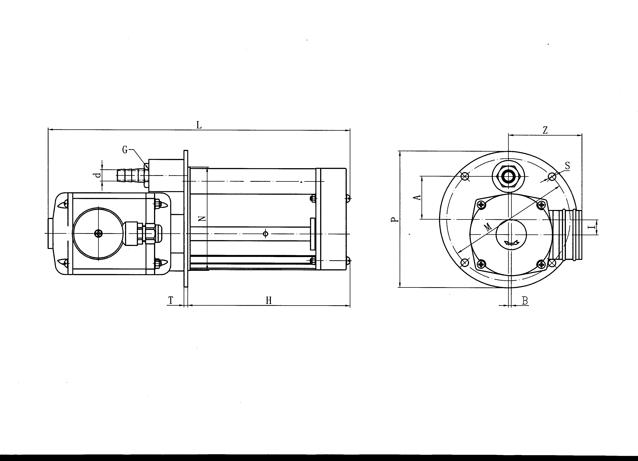

型号 | H | L | N | P | T | A | Z | B | I | M | S | d | G
AB-6A | 152 | 285 | 90 | 120 | 4 | 40 | 70 | 3 | 11 | 105 | 6 | 6 | G3/8”
AB-12A | 152 | 285 | 90 | 120 | 4 | 40 | 70 | 3 | 11 | 105 | 6 | 11 | G3/8”
AB-25A | 172 | 320 | 110 | 145 | 4 | 46 | 78 | 3 | 16 | 130 | 8 | 14 | G1/2”
AB-50A | 172 | 320 | 110 | 145 | 4 | 46 | 78 | 3 | 16 | 130 | 8 | 18 | G1/2”
AB-100A | 250 | 450 | 165 | 200 | 8 | 57 | 90 | 11 | 25 | 180 | 8 | 25 | G1”
AB-200A | 255 | 455 | 165 | 200 | 8 | 57 | 90 | 11 | 25 | 180 | 8 | 33 | G3/2”

JCB电泵外形及安装尺寸
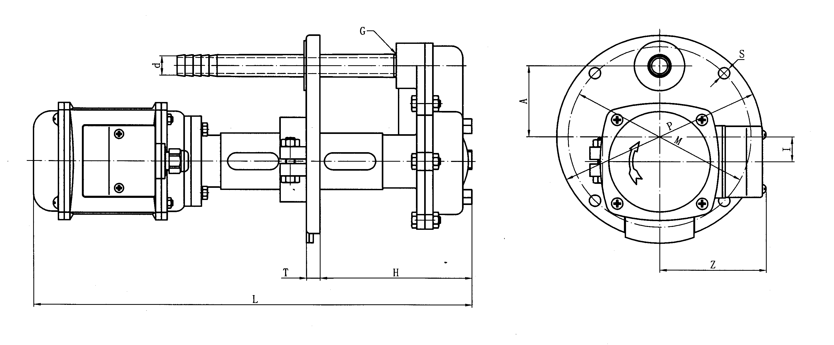

型号 | H | L | P | T | A | Z | I | M | S | d | G
JCB-22 | 70-195 | 384 | 180 | 12 | 63 | 95 | 22 | 160 | 10 | 17 | G1/2”
JCB-45 | 70-195 | 384 | 180 | 12 | 63 | 95 | 22 | 160 | 10 | 26 | G3/4”
JCB-90 | 80-280 | 545 | 250 | 12 | 95 | 110 | 30 | 225 | 10 | 30 | G1”

DB(DOB)电泵外形及安装尺寸
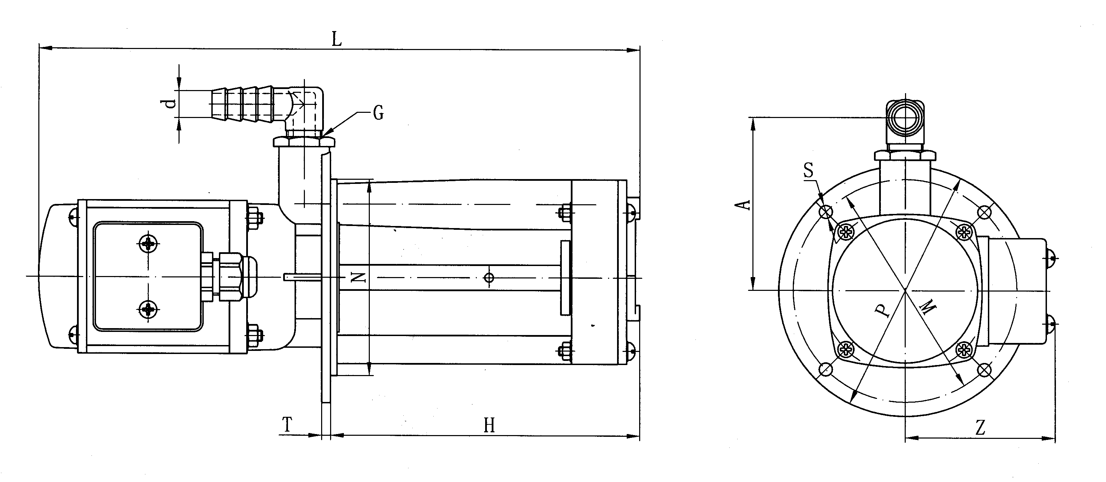

型号 | H | L | N | P | T | A | Z | M | S | d | G
DB-6A | 142 | 275 | 90 | 115 | 4 | 82 | 70 | 102 | 6 | 11 | G3/8”
DB-6B | 92 | 225 | 90 | 115 | 4 | 82 | 70 | 102 | 6 | 11 | G3/8”
DB-12A | 142 | 275 | 90 | 115 | 4 | 82 | 70 | 102 | 6 | 13 | G3/8”
DB-12B | 92 | 225 | 90 | 115 | 4 | 82 | 70 | 102 | 6 | 13 | G3/8”
DB-25A | 165 | 318 | 120 | 166 | 4 | 108 | 95 | 150 | 8 | 17 | G1/2”
DB-25B | 112 | 265 | 120 | 166 | 4 | 108 | 95 | 150 | 8 | 17 | G1/2”
DB-50A | 165 | 318 | 120 | 166 | 4 | 108 | 95 | 150 | 8 | 19 | G1/2”
DB-50B | 112 | 265 | 120 | 166 | 4 | 108 | 95 | 150 | 8 | 19 | G1/2”
DB-100 | 220 | 455 | 140 | 175 | 5 | 142 | 100 | 160 | 8 | 25 | G1”

注：AOB 及DOB均为单相电泵,其外形及安装尺寸均和相应的AB或BD电泵一致。

